Design and Development of a Mobile-Based Civic Issue Reporting and Departmental Management System with Real-Time Tracking

|  |  |  |
| --- | --- | --- |
| R. Bhuvaneswari  Department of Computer Science and Engineering,  Rajalakshmi engineering College,  Chennai, India  bhuvanacheran@gmail.com | Pranav Sriram  Department of Computer Science and Engineering,  Rajalakshmi engineering College,  Chennai, India  230701235@rajalakshmi.edu.in | Nishanth Posa  Department of Computer Science and Engineering,  Rajalakshmi engineering College,  Chennai, India  230701213@rajalakshmi.edu.in |

*Abstract*— Efficient access to essential public services remains a critical need in both urban and rural areas. This paper presents GIVR, a mobile application developed to bridge the communication gap between citizens and public service authorities through a centralized and user-friendly platform. The application empowers users to report civic issues—such as potholes, malfunctioning streetlights, water leaks, and garbage accumulation—directly to the appropriate municipal departments. With features like real-time location tagging and multimedia uploads (photos, videos, voice notes), the platform ensures accurate and detailed reporting. Users can monitor the progress of their complaints and receive timely updates through in-app notifications. The system also includes verified profiles of municipal workers and departments, promoting transparency and accountability. By streamlining the interaction between citizens and local governance bodies, GIVR enhances responsiveness, fosters trust, and encourages community engagement.

*Keywords— public service delivery, civic engagement, complaint reporting app, municipal governance, smart city, GIVR*

# Introduction

Timely and effective communication between citizens and public service providers is essential for maintaining urban infrastructure, public health, and overall quality of life. Traditional complaint systems often suffer from inefficiencies such as delayed responses, lack of accountability, and inadequate tracking mechanisms. These issues are even more pronounced in rural or under-resourced regions, where communication gaps and bureaucratic delays result in prolonged inaction and citizen dissatisfaction [1].

Recent developments in mobile technology, internet accessibility, and location-based services have paved the way for modern solutions to public service reporting. Mobile applications, in particular, offer an opportunity to simplify and centralize the process by which citizens report civic issues—ranging from road maintenance to waste management—and track their resolution. These platforms help streamline communication, reduce ambiguity in requests, and ensure a traceable workflow for service departments.

This paper introduces a mobile-based Public Service App that enables users to report civic problems in real time using geolocation and multimedia inputs. The system is designed to provide transparency through complaint status tracking, direct communication with relevant authorities, and verified departmental profiles. The aim is to foster civic engagement, reduce service delays, and support more efficient urban and rural governance.

The rest of the paper is structured as follows: Section II reviews related works and existing applications for public service and issue reporting. Section III outlines the proposed system’s architecture and its core functionalities. Section IV discusses the tools and technologies used in development. Section V presents the user interface and workflow. Section VI concludes with potential enhancements and future directions.

# LITERATURE REVIEW

Public service delivery systems need not just efficient administrative structures but also interfaces that help bridge the gap between people and the authorities. Many web and mobile applications have been added over the years to report civic problems such as garbage collection, leaks in water pipes, potholes, and damaged public infrastructures. Though promising, many current systems have shortcomings of limited interactivity, non-scalability, and feeble feedback loops. This section considers current platforms and research contributions in the area of public service reporting and citizen engagement tools.

Raj, Kumar, and Tiwari [2] presented a mobile civic complaint registration system with an aim to simplify citizen- municipal corporation interactions. The application had location tagging functionality and accommodated users to describe their issues via structured questionnaires. It didn't have a visual interface to report and a real-time complaint monitor, and hence timings of solution were not trusted by the users.

Sharma and Tripathi [3] suggested a web and Android- integrated municipal management system. The system had a user-friendly interface where people could easily report complaints pertaining to roads, streetlights, and sanitation. Even with the platform allowing administrators to classify and allocate grievances, there was no mechanism by which users could know whether the complaint was made to them or not without manual indication by the authorities, resulting in a one-way interaction process.

The "Swachhata" app [4], introduced by the Government of India under the Swachh Bharat Abhiyan program, is one of the more effective examples of citizen reporting within a public-private platform. Citizens can report public toilet issues with uploads of photos and geolocation. Complaints are channeled directly to the municipal personnel and made visible to everyone. Though the app shows high usage in the metros, limited category range (mainly issues related to cleanliness) and some time lag between complaint filing and response have contributed to negative user feedback, predominantly in the smaller towns.

Agrawal et al. [5] investigated public utility monitoring with a mobile app that enabled users to report electrical faults, faulty traffic signals, and issues related to water. Their system was based on GPS tagging and complaint submission forms. The utility, however, did not feature multimedia upload or mutual communication, and this jeopardized the effectiveness of the system in case of uncertain or emergency reporting.

There is another pertinent system that is "mGovernance," explained by Varghese and Kumar [6], that focuses on government-to-citizen service delivery through mobile applications. Though the system contains different categories of services and a degree of interactivity, the system is more oriented towards delivering static information like tax dues, bill payment, and certificates and not issue report interactivity.

Mehta et al. [7] presented a more sophisticated solution that included complaint status updates, service level deadlines, and escalation. Both a back-end dashboard for the officials and a cell-phone interface for the citizens were part of the system architecture. It was dependent on continuous internet connectivity and didn't have offline capability or SMS-based failback, impacting usefulness in areas with weak network coverage.

It is exemplified by the "Connect2Gov" framework presented by Saini and Verma [8], where a unified platform that enabled centralized filing of citizen grievances was the prime point of discussion. It centred on integrating different departments at a single digital interface. But the paper reported issues in departmental coordination and synching of data, and this would result in inefficiencies if not resolved.

There have been some experiments with community- based schemes. Dubey and Sharma's "Neighbour Net" app [9] engaged citizen groups and neighbourhood leaders together to resolve lesser civic issues jointly prior to taking them to the authorities. This bottom-up approach proved promising in suburban areas but necessitated the participation of a proactively engaged community and therefore proved not to be feasible in areas with limited digital literacy or community activism.

Moreover, Bhardwaj et al. [10] created a public grievance redressal system based on feedback wherein the effectiveness of services and solutions were rated by users. This rating function allowed the monitoring of performance measures by municipal agencies but was dependent upon user involvement and lacked direct escalation or reassignment features. The popular "Fix My Street" platform in common use in the United Kingdom [11] has become popular due to its enabling people to report neighbourhood concerns such as graffiti, fly- tipping, and broken pavements. The platform sends complaints to the relevant council by geolocation. One of the biggest strengths is its user-friendly interface and feedback via a visual map. Its limited international language coverage and reliance on cooperation with councils are drawbacks. Fig.1 shows the user flow diagram.

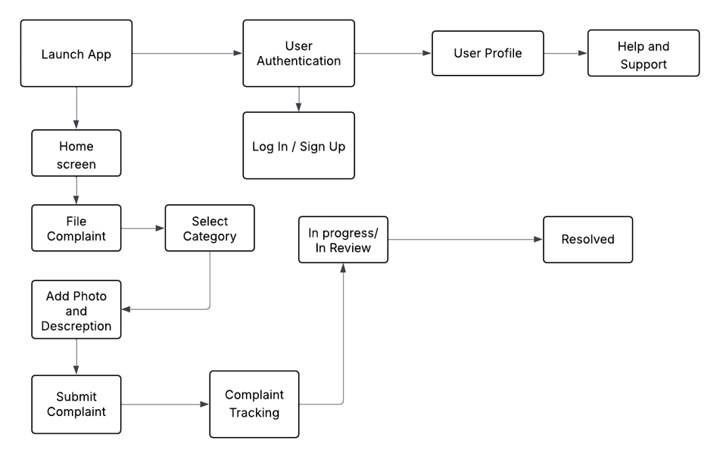

Fig.1.Civic Issue Reporting App – User Flow Diagram

# PROPOSED SYSTEM

The proposed mobile-based public grievance reporting platform, Fix It Now, is designed to streamline the process of identifying, reporting, and resolving public infrastructure and civic issues. This system acts as a bridge between citizens and municipal authorities, allowing for efficient and transparent communication regarding common public complaints such as potholes, streetlight failures, drainage clogs, water leakage, and sanitation hazards. It provides a location-aware, image- supported complaint filing mechanism that enhances accountability, accelerates resolution times, and promotes civic engagement.

Upon launching the app, users are presented with a simple, intuitive interface that showcases their current location using Google Maps integration. Users can then file a complaint by selecting the issue category (e.g., Water, Electricity, Road, Sanitation, or Drainage), writing a brief description, uploading an image or video, and submitting the report. Each report is automatically tagged with the user’s GPS location, timestamp, and issue category.

The system’s backend processes the incoming complaints and routes them to the corresponding government department—such as the Public Works Department (PWD), Water Supply & Sewerage Board, or Municipal Health Office—based on predefined classification rules. A government-facing dashboard interface allows departmental officers to view, sort, and prioritize incoming complaints, update status reports, and interact with complainants when necessary.

To enhance transparency and public participation, the app features a community voting system, enabling users to upvote pressing issues within their locality. This helps authorities gauge public urgency and take timely action. Citizens can also track the real-time status of their complaints, receive push notifications on progress, and provide feedback upon resolution.

In its current form, the system is rule-based and department-mapped; however, future versions will integrate Artificial Intelligence (AI) and Machine Learning (ML) models to automatically classify complaints using text clustering and natural language processing (NLP). These enhancements will enable more accurate department tagging and smarter prioritization of issues based on severity, frequency, and public engagement.

Key Features:

The FixItNow app includes a complete set of features specifically designed to streamline the process of citizen complaints. The features have been crafted to facilitate better public to civic bodies communication, accelerate complaint solving, and maintain transparent government functions. Some of the main features designed in the current implementation are included below.

1. Multi-Category Complaint Submission

The service supports lodging of civic grievances under different public service sectors such as Water Supply, Electricity Problems, Road Damage, Drainage Overflow, and Sanitation Issues. Users have a guided interface where they can choose the category of the issue that occurs to them, enter a brief description of the issue, and report the issue and have it further taken care of.

1. Location Tagging via GPS

All complaints submitted are geotagged with the GPS feature found on the mobile device of the user. This helps identify the location of the issue with accuracy by the respective departments of the government, minimizing ambiguity and response time. It also supports the visualisation of clusters of complainants by the government dashboard.

1. Image and Media Upload Support

For better understanding and authentication of issues reported, the app permits users to upload photos and short videos with their text descriptions. This feature accommodates visual proof, a factor that can be very significant in confirming the nature and priority of the complaint.

1. Manual Departmental Routing System

In contrast to the automated routing, the new system has manual complaint routing feature. Administrative staff or department coordinators review submitted complaints via the government dashboard. Depending upon category and content of the complaint, they are routed to the corresponding municipality department like the Public Works Department (PWD), Water Board, or the Sanitation Department to be further processed and resolved.

1. Real-Time Grievance Monitoring

Once a complaint has been submitted, the user can monitor its status in a special "My Complaints" area. The interface shows the issue's status at the time—pending, in progress, or resolved—as well as time-stamped updates and any uploaded comments or photos by the department. Automated Alerts to Emergency Contacts

1. Government Dashboard Interface

A specific web-based dashboard has been created to be accessed by administrative staff and government officers. The dashboard has an easy-to-use interface to view complaints based on department, location, or priority. Officials are able to allocate issues manually, flag status updates, send messages to complainants, and have the ability to report complaint patterns and timelines of closure.

1. Status Notifications

In order to be transparent and retain user interest, the application sends users instant updates concerning the status of a complaint. Users are notified upon acknowledgment, assignment, update, or closure of a complaint, thus keeping them posted at each stage.

1. User Account Management

The platform has a feature that supports authenticating users securely with Firebase Authentication. Upon registration, users can also maintain personal information like name, mobile phone number, and email. The account area also gives users an opportunity to view the complaint history, voting history, and notification preferences.

1. Offline Draft Mode

The application caters to users in areas with poor internet connectivity by enabling complaints to be stored offline in draft mode. Users can later view and send the drafts when connectivity becomes available, preventing users from being limited by connectivity issues in filing public grievances.

1. Community Voting System

FixItNow has a public voting feature where users can upvote previously submitted issues in their area. This enhances collective prioritization by allowing the authorities to identify and act upon the most crucial public issues that have a wider citizen population impacted.

# TOOLS AND TECHNOLOGIES USED

Developing a scalable and citizen-centric issue reporting application like FixItNow necessitates the integration of diverse tools and technologies to ensure smooth user experience, data synchronization, modularity, and security. The chosen stack supports real-time performance, user- friendly design, and platform independence while laying the groundwork for future AI and ML enhancements.

1. Mobile Development Framework

Objective: To create a user-friendly and responsive interface that is compatible with both Android and iOS operating systems.

Tools: The development is done with the Flutter SDK, which allows a high-performance UI with a widget-based design. The logic and the interaction layer are done with the Dart programming language, providing native-like speed and smooth animations across devices.

1. Database Management Systems:

Functionality: To store and maintain application data, such as user profiles, complaint histories, departmental data, and feedback logs.

Tools: Cloud Firestore is designed to store data remotely and facilitate real-time data synchronization among administrators and users. Its document-based architecture allows flexibility to store semi-structured complaint data together with related metadata.

1. Location Services & Mapping:

Objective: To offer accurate geolocation services to help identify complainant locations and improve spatial awareness both for users and department personnel.

Google Maps Flutter is integrated to provide a visualization of user and complaint geolocations on a dynamic map interface.

Geolocator is used to obtain device location coordinates in real time to enable location mapping of reported issues.

Location-based service discovery allows dynamic retrieval of nearby service centers and corresponding authorities, enhancing routing efficiency.

1. User Authentication:

Purpose: To ensure secure and personalized access to the application for all users.

Tools: User credentials are authenticated using Firebase Authentication, which supports both email/password login and third-party authentication providers such as Google. Additionally, OTP-based phone number verification is integrated to strengthen identity validation and user trust.

1. Messaging and Notifications:

Purpose: To facilitate real-time alerts and communication between users and administrative departments. Technologies:

Firebase Cloud Messaging (FCM) is utilized for push notifications, ensuring users receive timely updates on complaint status and system alerts.

In-app notifications are implemented to provide on-screen alerts without interrupting the user experience, fostering seamless communication during active sessions.

1. Security:

Purpose: To safeguard sensitive user information and maintain secure interactions across all modules of the application.

Technologies:

Secure API key management is implemented to prevent unauthorized access to backend services.

Firebase Security Rules are configured to enforce access control policies on Firestore data and authentication processes, maintaining data integrity and user privacy.

1. Cloud services:

Purpose: To offer a scalable and reliable backend infrastructure that supports authentication, real-time database operations, and asynchronous messaging.

Tools: Firebase serves as the primary backend-as- a-service (BaaS) platform, offering integrated modules for Authentication, Firestore, Cloud Functions, and Messaging.

1. GitHub and Git:

Purpose: To manage source code versions, enable collaborative development, andstreamline deployment workflows.

Technologies: Git, a distributed version control system, is used in conjunction with GitHub, a remote repository platform, to track development history, manage issue tracking, and coordinate contributions among team members.

1. Development Environments:

Purpose: To provide robust and efficient tools for application development, testing, and deployment.

Tools:Visual Studio Code (VS Code) and Android Studio are employed as the primary Integrated Development Environments (IDEs), offering intelligent code assistance, Flutter SDK integration, emulators, and performance debugging utilities.

1. Performance Monitoring & Analytics:

Purpose: Tracks system usage, crash reports, and user behavior for continuous improvement.

Tools: Firebase Analytics, Logger

# IMPLEMENTATION

Developing the *FixItNow* public service complaint application involves the integration of modern mobile frameworks, real-time geolocation APIs, multimedia handling, cloud-based data storage, and department-specific routing systems. The implementation is designed to ensure civic transparency, real-time responsiveness, and structured coordination between citizens and government departments.

1. User Registration and Authentication:

User onboarding initiates with a secure registration screen where individuals input essential information including full name, mobile number, email address, and password. This data is authenticated and stored using *Firebase Authentication*, supporting both email/password-based login and third-party providers such as Google. OTP-based phone verification is implemented to enhance identity validation. Fig 2. shows the registration screen, which collects user credentials in a structured form with input validation and navigation prompts for existing users.

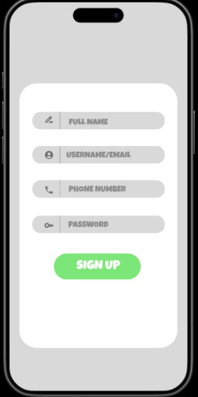

Fig. 2. SignUp Page

Users can choose to log in using either their phone number or email/password, with third-party sign-in support for Google and Apple accounts. Fig 3.a. depicts the phone number login interface, offering OTP-based verification. Fig 3.b. illustrates the email and password login screen, with options for social logins and user-friendly toggles between login modes.

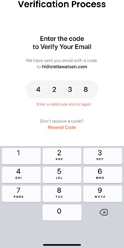 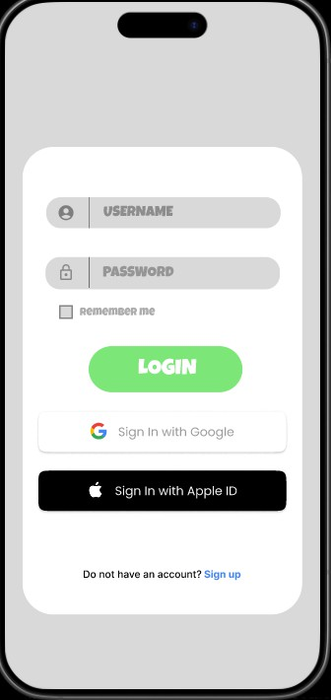

Fig. 3.b. Login Page

Fig. 3.a. Verification Page

1. Home Screen:

Upon successful login, users are directed to the Home Upon successful login, users are directed to the *Home Screen, which serves as the primary interface for submitting civic issues. The application automatically fetches the user's current location using the **Google Maps API* and displays it as the default complaint location, which can be adjusted if needed.

Quick-action buttons allow users to choose issue categories such as *Water, Sanitation, Electricity, Roads, or Drainage*. Users are prompted to provide a description of the problem, upload optional media (images), and submit the report for review. Each report is time-stamped and geo- tagged.

Fig. 4 displays the home interface, showing category icons, real-time map embedding, and an "Add Complaint" floating button. Fig 5. shows the expanded map view allowing to track the areas.

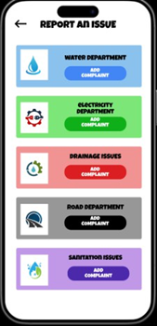 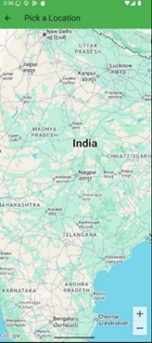

Fig. 5. Map view

Fig. 4. Home Page

1. Departmental Complaint Routing:

Once submitted, the complaint is automatically assigned to a corresponding civic department based on its category. Each category maps to a specific local authority such as:

Water-related: Water Supply and Sewerage Board

Road issues: Public Works Department (PWD)

Electricity: State Electricity Board

Sanitation: Municipal Health Department

Drainage: Urban Drainage Management Cell

The backend filters complaints using a rule-based mapping system and queues them in the departmental dashboard.

1. Complaint Tracking and Resolution Status:

The *Status Tracker* module allows users to monitor their complaint through four stages: Submitted, In Review, In Progress, and Resolved. Updates are pushed in real-time using Firebase Cloud Messaging (FCM). Notifications are also sent when the status changes.

1. Issue Reporting Interface:

Quick-action buttons allow users to choose issue categories such as Water, Sanitation, Electricity, Roads, or Drainage. Users are prompted to either add a written description and a supporting image of the issue or directly share their current location with the concerned department for prompt intervention. Additionally, the interface allows uploading optional media (images) to provide visual evidence, further enhancing the contextual understanding of the complaint. Each report is time-stamped and geo-tagged to ensure traceability and location accuracy.

Fig. 6 displays the home interface, showing category icons, real-time map embedding, an "Add Complaint" floating button, and the enhanced multimedia input functionality.

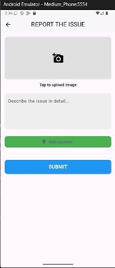

Fig. 6. Report Section

1. Department Dashboard for Government Use:

Each authorized department official is given a role-specific login to access a *Departmental Dashboard* that shows complaints filtered by category, location, and urgency. Officials can mark complaints as resolved, add notes, or request more details from users. Fig. 7 illustrates the dashboard view for the Public Works Department.

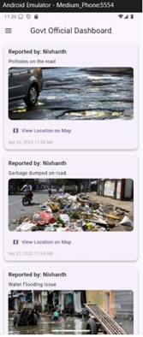

Fig. 7. PWD Dashboard

1. User Profile and Complaint History:

Users can access their *Profile Tab* to edit personal details, view previously submitted complaints, and track department responses. Fig. 8.a and Fig. 8.b presents the menu bar and the profile overview screen. Fig. 8.c shows detailed complaint history with timestamps.

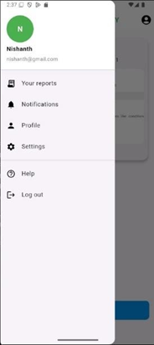 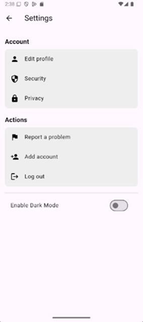

Fig. 8.b. Profile page

Fig. 8.a. Menu Bar

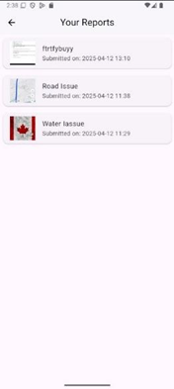

Fig. 8.c. Complaint History

1. Help and Support Feature:

To enhance user accessibility and promote ease of navigation, the application incorporates a Help and Support feature accessible via the main menu and complaint submission screens. This feature provides a categorized FAQ section, contact information for local civic departments, and a live chat option during working hours.

Users can search for topics such as how to file a complaint, edit submissions, track status, or contact departments. Additionally, there is an embedded guide that provides step- by-step visuals on submitting issues, voting on complaints, and managing user profiles. For real-time assistance, users may also initiate a support request, which opens a direct messaging window with the app’s helpdesk team.

This feature is crucial for first-time users and ensures inclusivity by assisting individuals unfamiliar with digital reporting platforms. Fig. 9 demonstrates the Help Centre interface, with expandable topics, search functionality, and contact options for further guidance.

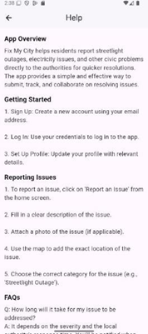

Fig.9. Help Page

# CONCLUSION

We introduced the concept and development of a one-stop government public service application designed to simplify citizens' interactions with key government services. It incorporates fundamental features like real-time service requests, problem reporting, customer feedback submission, and service monitoring for a seamless bridging of the communication chasm between citizens and government agencies. The app's user-friendly, easy-to-use interface makes the application accessible across ages and technical abilities. Our architecture was designed to be scalable, modular, and strong on security of user data while ensuring service reliability by using cloud-based infrastructure and encryption protocols. The inclusion of geo-tagging, image uploading, and categorization features allows for accurate reporting and timely resolution of issues by respective departments. The backend is designed for quick data processing and instant status reporting, thus optimizing administrative body operational efficiency.

Initial pilot tests and citizen feedback have shown the application's high potential for enhanced delivery of public services, transparency, and enhanced levels of citizen participation. The user activity metrics reflected the citizens' readiness to embrace the platform as a mainstream means of accessing the city's municipal services. Future development will target the integration of AI-based analytics for predictive management of services, helping authorities anticipate and resolve issues before they happen and make more effective use of available resources. Additionally, initiatives will be initiated towards incorporating multi-lingual support and offline working to take the application beyond the reach of rural and underserved regions and provide equal access to all classes of society. Future plans also include integrating blockchain technology for audit-proof service logs and enhancing cooperation between third-party public service providers for the development of a harmonious smart governance platform.

Ultimately, the suggested application marks a substantial step towards more responsive, inclusive, as well as technology-enabled public service management in line with the overall objectives of smart city initiatives and digital government transformation.

##### References

1. S. R. Sharma and A. Gupta, “A Mobile-Based Citizen Grievance Redressal System for Urban Local Bodies,” International Journal of Computer Applications, vol. 178, no. 7, pp. 35–39, 2019.
2. M. S. Rao, “Design and Implementation of an Android Based Public Safety Application,” IEEE International Conference on Smart Technologies for Smart Nation (SmartTechCon), Bengaluru, India, 2017, pp. 1101–1106.
3. Kumar and R. Singh, “Geolocation and Mapping Solutions in Civic Applications: A Case Study,” Proceedings of the 2021 IEEE Conference on Sustainable Urban Development, pp. 124–129, 2021.
4. P. Chatterjee, “Role of AI Chatbots in Civic Tech Applications,”

Journal of Urban Informatics and Artificial Intelligence, vol. 3, no. 2, pp. 88–95, 2022.

1. Ministry of Housing and Urban Affairs (MoHUA), Government of India, “Smart Cities Mission Guidelines,” [Online]. Available: https://smartcities.gov.in. [Accessed: Apr. 23, 2025].
2. Patel and S. Ramesh, “Mobile Application for Municipal Complaint Registration and Tracking,” International Conference on Computational Intelligence and Communication Networks (CICN), 2018, pp. 452–456.
3. M. J. Miah, R. H. Khan, and T. Nasrin, “Smart City Complaint System: A Case Study on Location-Based Citizen Feedback,” IEEE Region 10 Conference (TENCON), 2020, pp. 1927–1931.
4. Smith and H. Lee, “Improving Civic Engagement through Smart Technologies: A Systematic Review,” IEEE Transactions on Emerging Topics in Computing, vol. 9, no. 3, pp. 1017–1028, 2021.
5. Dey, “Integration of AI-Powered Chatbots in Citizen Services: Opportunities and Challenges,” International Journal of Advanced Computer Science and Applications (IJACSA), vol. 11, no. 6, pp. 67– 73, 2020.
6. B.K. Mohapatra, “Secure Mobile Application Development with Firebase and Flutter,” IEEE International Conference on Advanced Computing and Communication Technologies (ACCT), 2022, pp. 203– 208.
7. S. Desai and A. Bhatt, “Analyzing User Feedback on Civic Services via Mobile Applications Using NLP,” IEEE International Conference on Data Science and Advanced Analytics (DSAA), 2021, pp. 501–506.
8. N. Ghosh and M. Prasad, “Smart Government Portals and Complaint Resolution in Indian Municipalities: A Comparative Study,” Journal of e-Government Studies and Best Practices, vol. 2020, pp. 1–10, 2020.
9. H. Lee, "Public Service Delivery on Mobile Apps: Factors of Diversification and Coproduction," Int. J. Public Admin., vol. 47, no. 3, pp. 159–171, 2022
10. T. Tang, J. Hou, D. L. Fay, and C. Annis, "Revisit the drivers and barriers to e-governance in the mobile age: A case study on the adoption of city management mobile apps for smart urban governance," J. Urban Affairs, vol. 43, no. 4, pp. 563–585, 2021.
11. T. Isagah and M. A. Wimmer, "Mobile government applications: Challenges and needs for a comprehensive design approach," in Proc. 10th Int. Conf. Electronic Government, 2011, pp. 148–159.